3 DAYS 2 NIGHTS FREE & EASY KUALA LUMPUR PACKAGE

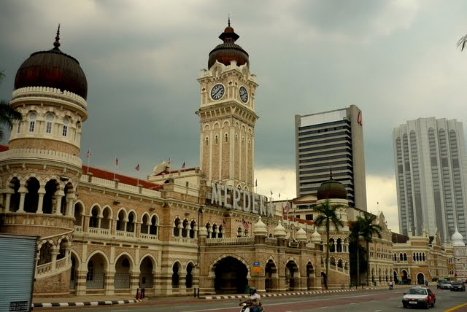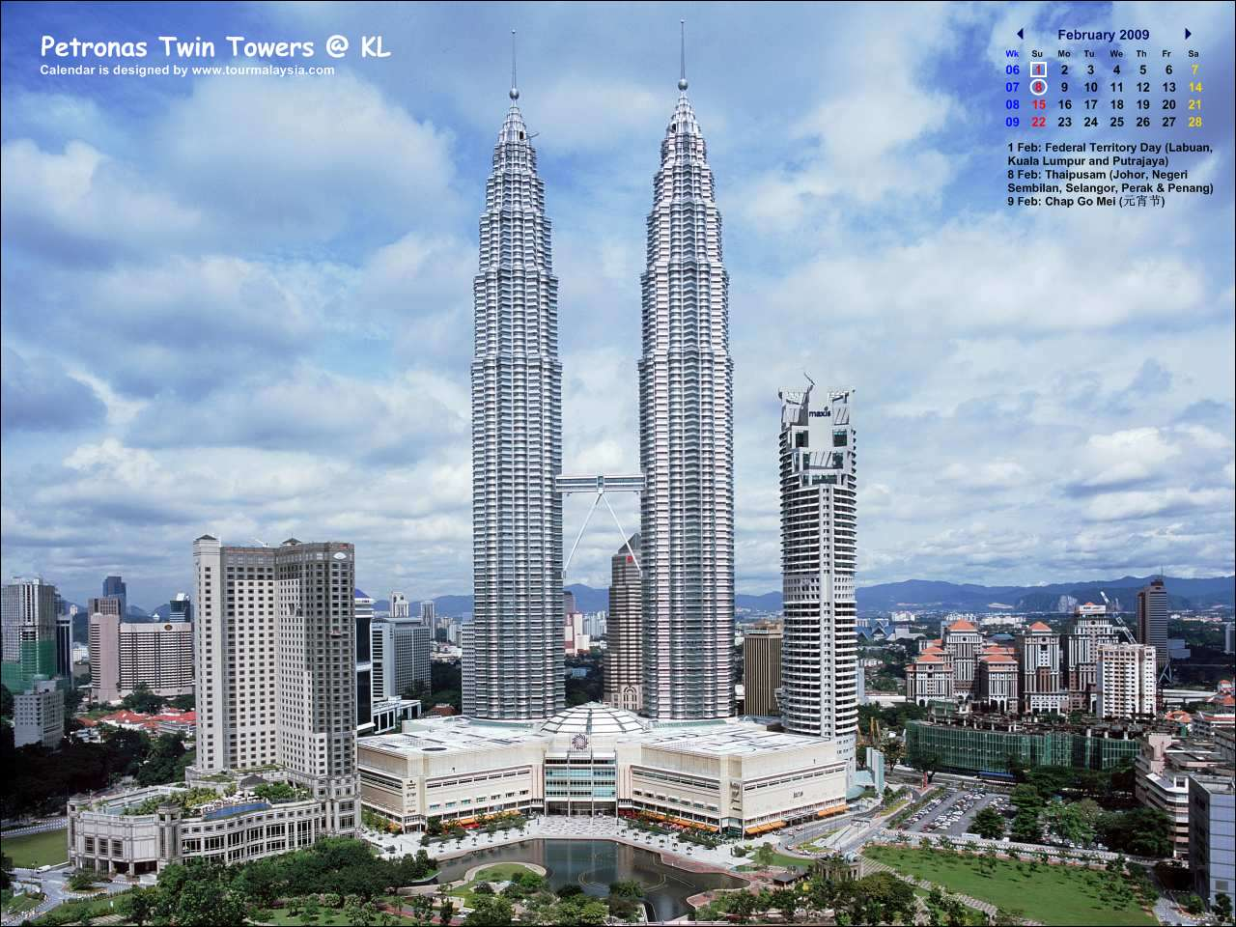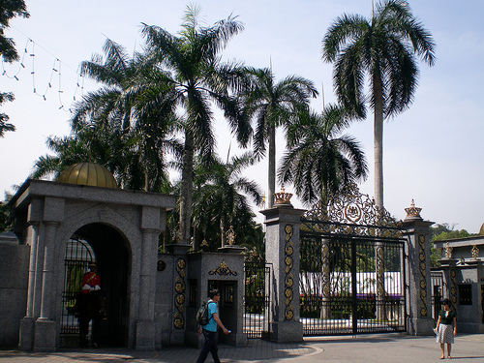

Hotel | Twin / Triple  (per person) | Child with extra bed | Child without bed | Single supplement additional
(3*) Hotel Sentral Pudu | RM 430.00 | RM 335.00 | RM 250.00 | RM 150.00
(4*) Coronade Hotel | RM 530.00 | RM 420.00 | RM 315.00 | RM 255.00
(5*) Maya Hotel | RM 665.00 | RM 525.00 | RM 395.00 | RM 390.00

ITINERARY :

Day 1 ARRIVE KUALA LUMPUR
Arrive KUALA LUMPUR airport , check in hotel .

Day 2 KUALA LUMPUR (BREAKFAST)
Breakfast at hotel, proceed to Kuala Lumpur half day City tour – National Monument , Independence Square , National Mosque , King Palace , Petronas Twin Tower ( photo stop) . Afternoon , free at leisure .

Day 3 KUALA LUMPUR – OUT (BREAKFAST)
Breakfast at hotel, free until transfer to airport for your departure

Package Inclusive :
~ Transfer in/out.
~ 2 Nights accommodation (Twin sharing).
~ 2 Breakfast.
~ Half day tour (seat in coach)

Package EXCLUDED :
~ Personal expenses.
~ Tipping.
~ Travel Insurance.
~ Domestic air ticket
~ Entrance fees for sightseeing.

REMARKS :
~ Rate is based on minimum 02 paxs and above.
~ The Hotel reserve all rights
~ Validity : Until March 2012 .
~ All the rate quoted base on RINGGIT MALAYSIA.

PEAK SEASON SURCHARGE :-
~ Sentral Pudu hotel additional surcharge @ RM 50.00 per room per night on 24 – 26 Dec &
31 Dec – 01 Jan 2012 .
~ Coronade Hotel additional surcharge @ RM 35.00 per room per night on 01 – 31 Dec 2011 .
~ Coronade hotel compulsory dinner on Christmas Eve & day @ RM 100.00 per adult .
~ Coronade hotel compulsory dinner on New Year @ RM 120.00 per adult .

